The Wri e Track

The Write Track journal features the unique writing talents of eight fourth grade boys at School 46. Volume 1, Issue 3

JANUARY 2008

Jalen & Alvin the Chipmunk

by Jalen Berry
One day me and Alvin was going to the store to get some chipmunk food. And I had $20 and it was one pack of chipmunk food left. Then a bully chipmunk named Brian. Then Alvin said, “give me back that food.” Then I said, “Give me back that food or I will break your bones. Then we took it home then I open my door then I saw a boxing ring. Then Brian said me and Alvin one on one for the chipmunk food. Then I count 1,2,3,4,5,6,7,8,9,10. Then I took a photo then I put the photo on the table then I cut it like a circle then I made championship belt and I made Alvin’s photo a spinner then he ate the chipmunk food when he was watching are episode that we create and it’s called Alvin the chipmunk and Jalen.

Inside this Issue
Dr. Peter Burch’s Update 2
46 School Is the Best, Michael Gonzalez 2
Lions, Jordain Billingslea 3
My Teacher Mrs. Ziegler, LeTrell Golden 3
Pokemon, Tavaho Hill-Childers 4
Our New Car, Devonte Burch 4
Foxes, Nygel McInnis 5
Penguins, John Jablonski 5


Dr. Peter Burch’s Update

In January, we made some changes to The Write Track. We are no longer meeting upstairs for lunch because I was unable to manage behavior. So now we are meeting in the cafeteria on Tuesdays and outside the classrooms, one on one, on Thursdays. Our focus is on spelling and storytelling and will be for the rest of the year. All spelling mistakes were corrected for publication. This week I will be reviewing each misspelled word with each writer. If you are interested in your son receiving free, after-school tutoring on writing skills, please contact me at 563-6930 or by email at peterandholly@gmail.com.

46 School is the Best

By Michael Gonzalez

Forty six school is the best because it’s a fun school and have pizza and field trip like Seabreeze and dancing celebrations and the teachers are nice like Mrs Ziegler and the principle Mrs. Delly and more and Mrs. Serour. The school is also fun because we do fun assignments like the listening assignment and a lot more. I love this school it is the super best! I’m going here the rest of the whole year. The End.
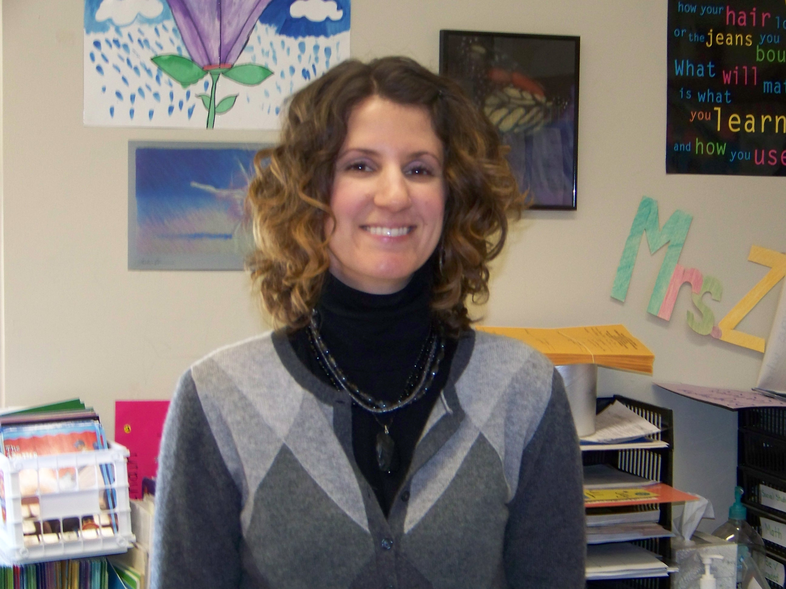

Lions

By Jordain Billingslea
I like lions because they kill and they roar loud. And they are vicious. And they jump far. I learned about lions from the zoo. They kill animals like deer for food and no other reason. If I saw a lion in the woods I would keep it as a pet. I would feed the lion chicken, pizza, hamburgers, pork chops, and broccoli until it grows up. I would name the lion killer. My dad had a dog named killer because when came to his mom’s house the dog would chase him and try to kill him until he ran inside the house. The End.

My Teacher Mrs. Ziegler

By LaTrell Golden
My teacher name is Mrs. Ziegler. She is nice and she is also a good teacher! Mrs. help me do different stuff in class. One thing I learned was how to respect everybody in the whole school. Respect is important because? When you grow up you can be a nice person. I’m grateful to have Mrs. Ziegler as a teacher.


Pokemon
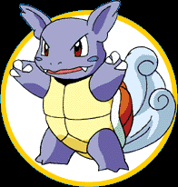

By Tavaho Hill-Childers
On today’s episode of Pokemon Ash, a 10 year old boy who wears a hat and a yellow and black jacket, tries to win his first badge. Okay I choose you Bulbasaur, and I choose you war turtle, let’s begin now. Go Bulbasaur razor leaf boom, direct hit. Now war turtle whirlpool Bulbasaur fainted the winner is Ron Smokes from twin leaf town. It’s okay Ash at least you tried your best. Yeah I’ll get him next time. The End.

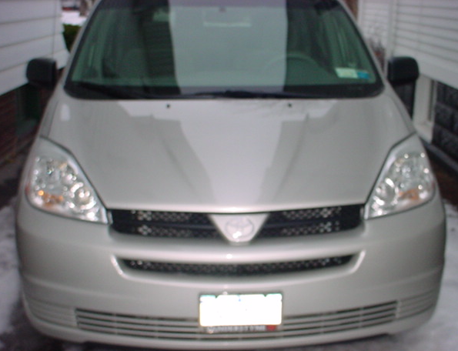

Our New Car
By Devonte Burch

It was the next morning that we were going to trade in Aslan. We went to a Toyota car dealership. We got there and we asked if we could trade in our car. First we took a test drive then we went back home. Then at 4:00 we were supposed to go to our mom’s doctor’s appointment but it was cancelled. So we went to Wegman’s to get some of mom’s stuff and then we went to get the car and we did. Yeah, we got it. I was so happy we got a van just in time for the baby to come. We have our own radio to listen to but we haven’t used it yet. It is so cool. I love it. This is the best thing we have ever got. Our car has cruise control for trips, back seats a big back. It feels bigger than our old car. It’s great to have a new nice car. And we got a car seat in their too.
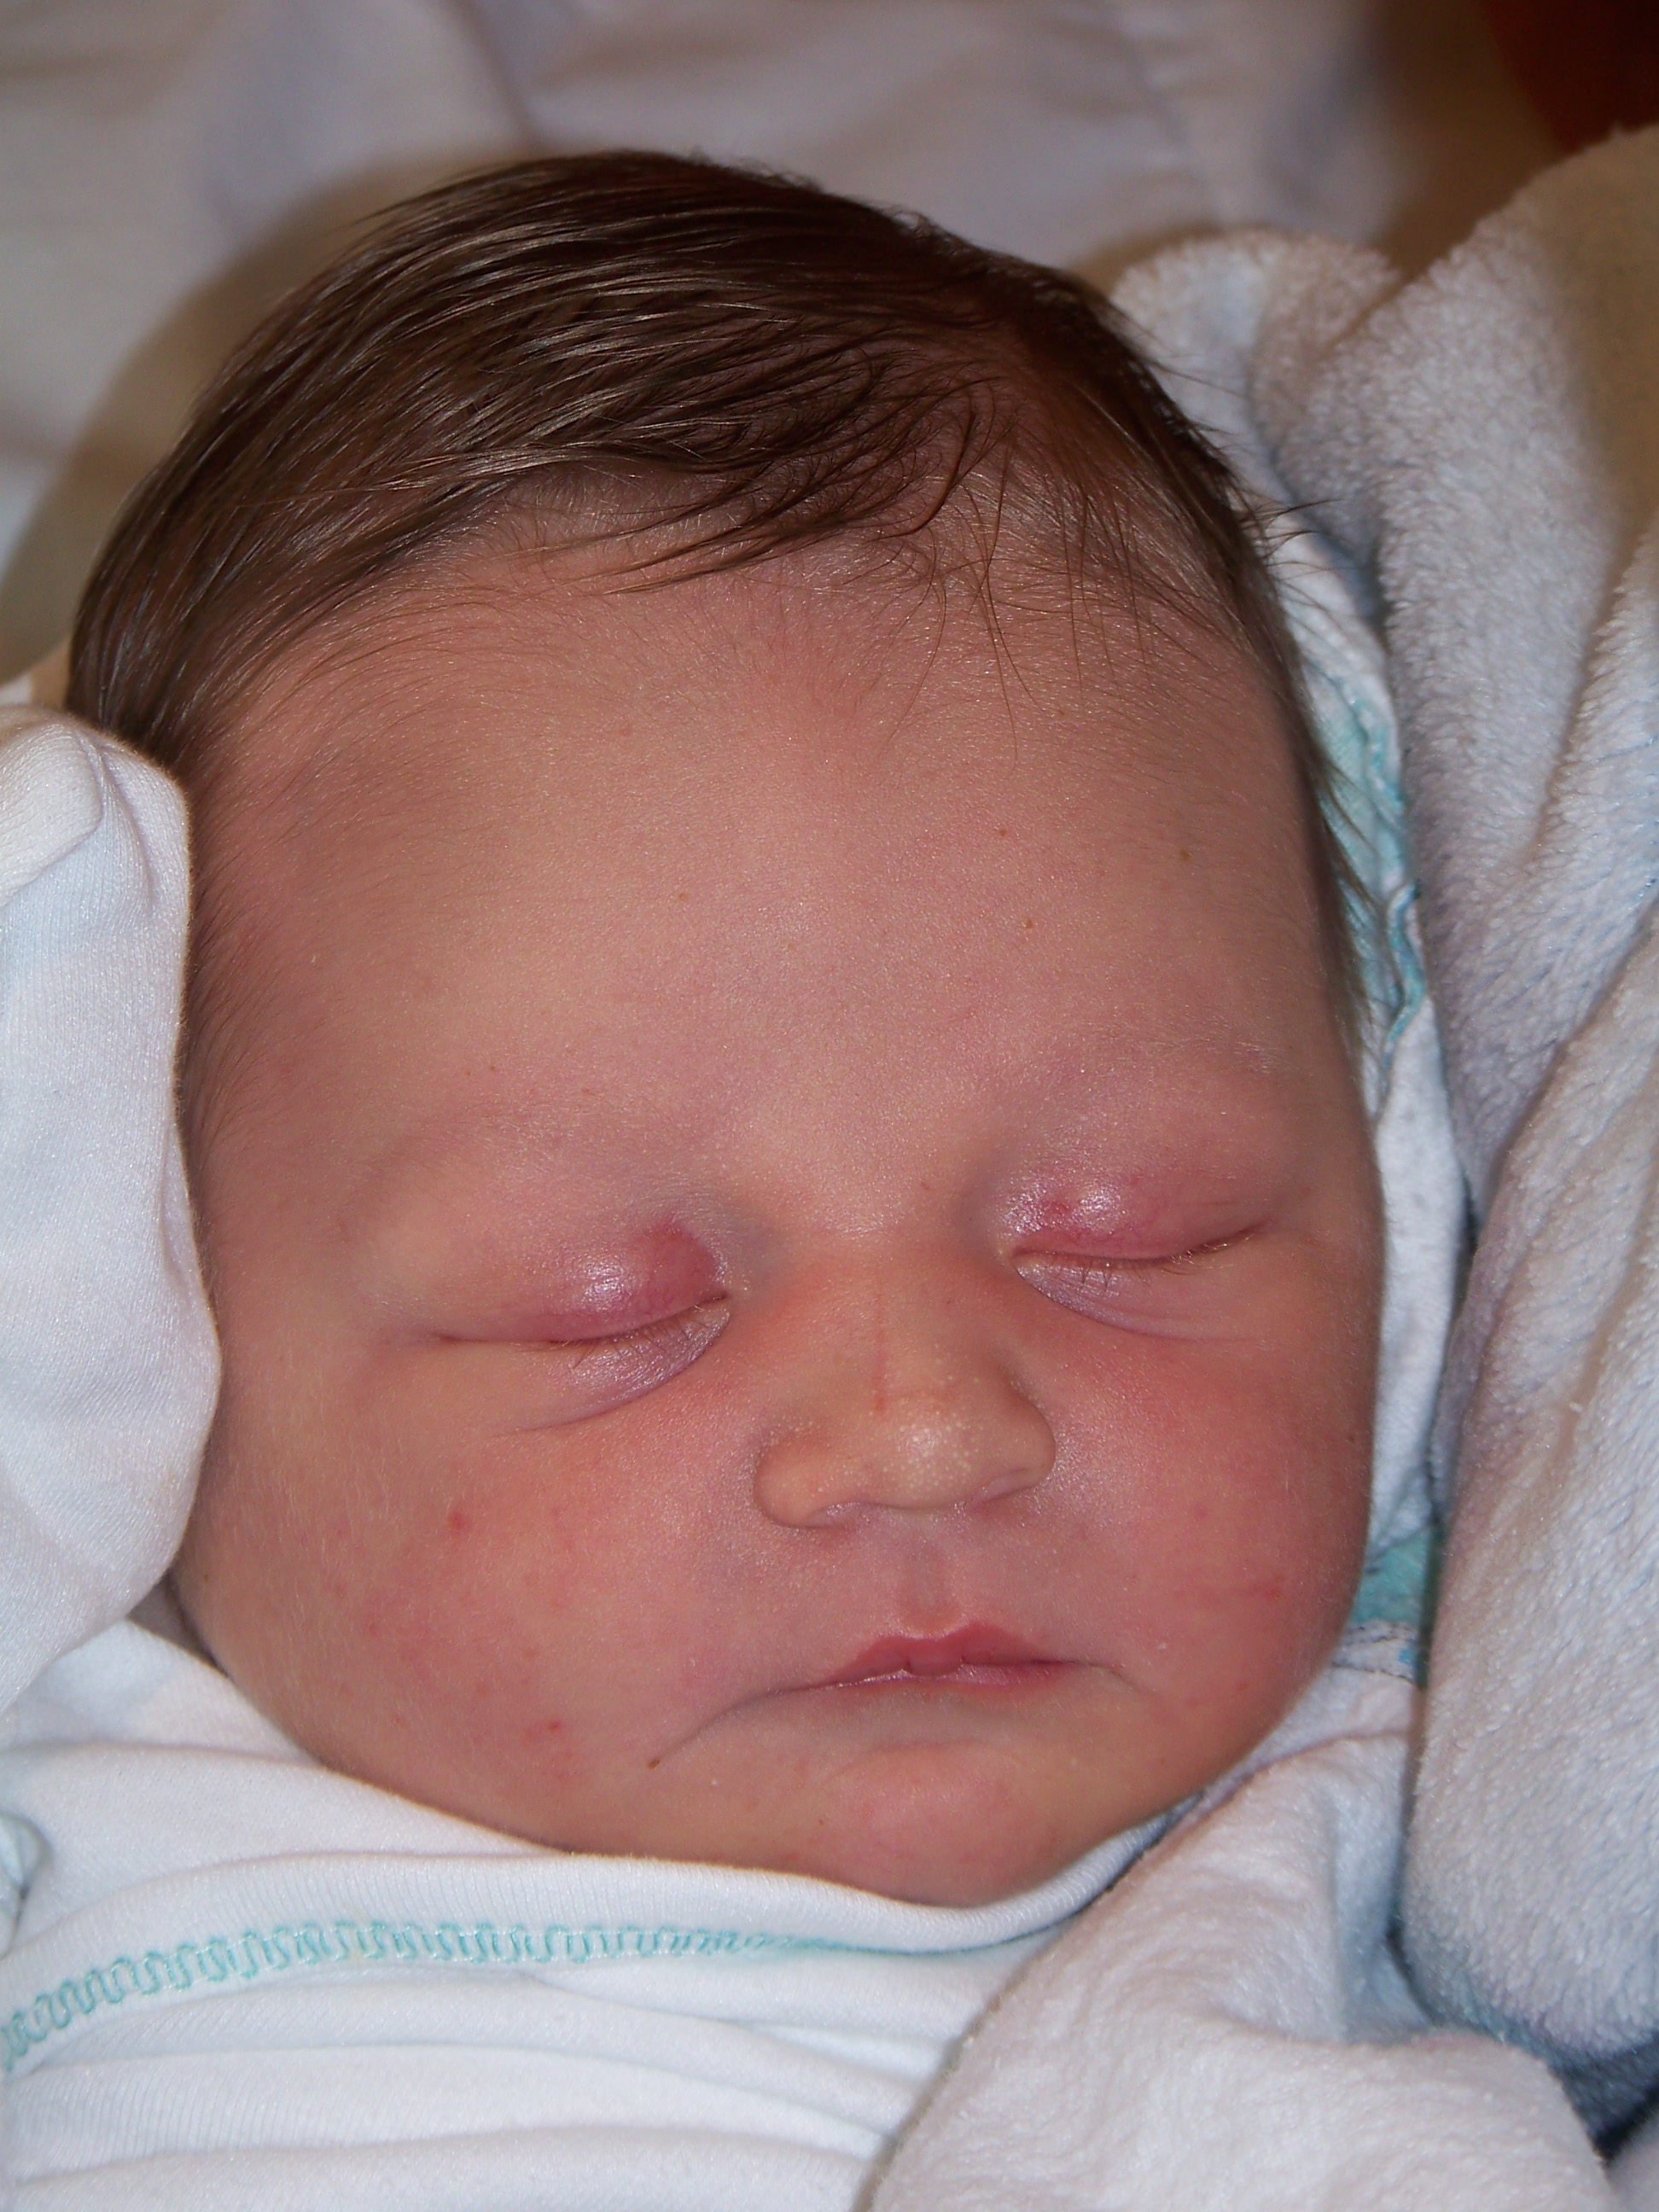

Jackson Burch, Devonte’s new baby brother
Foxes
By Nygel McInnis
I like foxes because they’re cool, because they’re sneaky. Foxes are related to coyotes, wolves. I read a book about foxes. I read that if a bear chases a fox a fox would cross the road but the bear would not. And that is my story about foxes.

Penguins

By John Jablonski
Penguins are very cool to me because
there are many different kinds.

