The Wri e Track

The Write Track journal features the unique writing talents of eight fourth grade boys at School 46. Volume 1, Issue 2

NOVEMBER 2007

My Trip to New York City

by John Jablonski

I loved it so much. It was so fun. I stayed at crowne plaza. I went in trump
Tower and I also went in toys r us and went in the wax museum. It took a long time to get there. It was a very, very good time.



Inside this Issue
Dr. Burch’s Update 2
Me and My Cousin, Jalen Berry 2
A Horse’s Friend, Michael Gonzalez 3
Scary Rides, Jordain Billingslea 3
LaTrell and Eric Go Hunting, LeTrell Golden 4
Chipmunks, Tavaho Hill-Childers 4
My Favorite Car, Devonte Burch 5
Wrestling, Nygel McInnis 5



Dr. Burch’s Update
Dr. Peter Burch, Ph.D.

I am still having a great time getting to know The Write Track boys. In October, we met every Tuesday and Thursday during lunch. This format allowed us to socialize and work on basic storytelling skills; however, personal needs could not be met. As a result, in late November we switched to a new schedule. On Tuesdays, we still meet as a group during lunch; however, on Thursdays I now meet one-on-one with the boys either before or after lunch. I am very grateful to Mrs. Ziegler and Ms. Matias for making this new format possible. In this issue, we continue our emphasis on correct SPELLING. Each article was edited for spelling mistakes. Writers were provided with a spelling correction list like the following: muesem is spelled museum; hert is spelled hurt.

Me and My Cousin

By Jalen Berry

Me and my cousin like to read and play game monopoly. And we like to play outside and play game like hide n seek and tag.


A Horse’s Friend

By Michael Gonzalez
This story is about 12 horses. One early day, I got out of the car. We had to go to the lounge. In lounge there are chairs and tables and hot cocoa and donuts for breakfast then we clean stalls. Horse manure smells like nothing then we groom the horses and put the saddle on and tighten it so it doesn’t slip off the horse’s back and then we get on the horse then we ride on the trail and walk gallop and trot and canter and ride them bareback and I fell off but it doesn’t hurt if you’re nto on concrete you have to hold on the reigns tight and keep your foot in the stirrup and you will be safe and don’t yell in front of the horse it will get scared and run away from you or kick you or bite that is what we do at the program.

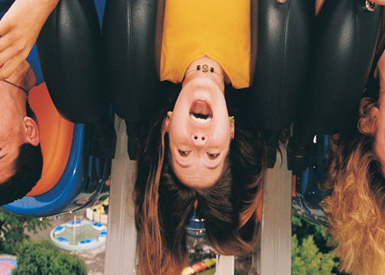
Scary Rides

By Jordain Billingslea

When I get on scary rides my stomach start to hurting and when I get off the rides I get dizzy when I get on another one I think I might throw-up when I get off the ride so I go home and watch tv then go to bed or play the game cube or the PlayStation or go outside to play or go to a fair to ride scary rides again or at Darien Lake to ride it some and stay their all day long I stayed at Seabreeze scary rides too like the eagle ride.

LaTrell and Eric Go Hunting, Chapter One

By LaTrell Golden
Once upon a time LeTrell and his cuz was in the woods. It was very dark outside in the woods but LeTrell his, cuz Eric was supposed to be at home at 9:00 o’clock but it was 10:17 o’clock by that time. LeTrell his, cuz Eric came back home at that time our parents said where was you two al l this time? We said we were hiking all that time we brought back food for everybody that night we all ate and went to bed and fell to sleep. A beautiful day.

Chipmunks
By Tavaho Hill-Childers

Chipmunks are one of nature’s delightful animals. In late summer chipmunks in Canada and the northern United States begin to store food in earnest for the long winter. they select seeds and nuts because these will keep well. If you see fruit on a fallen log or rock you know who has been here. most chipmunks live in forests and woods, But some are found at the edge of deserts and high in the mountains.

My Favorite Car
By Devonte Burch
My favorite car is a van. I like vans because the doors. If our family gets a car my mom will not let me play with the doors. I will obey her and do what she says so I wouldn’t be tempted. I like vans because they’re cool. Some vans have the door key where the windows are and that really cool. When I am older I am going to get my own van. I will get a dog for my children and another because of my wife. I will have children if we have more than that’s good.

Wrestling

By Nygel McInnis
Wrestling is cool because they fall of ladders and put their body on the line it has lots of action I going to see smack down at the blue cross arena. My cousins are going too. It’s going to be fun.

